YEAR 7 SCIENCE
PHYSICAL SCIENCES
INVESTIGATION - FACTORS AFFECTING FRICTION

Aim: (1) To determine how the type of surface affects the force of friction on a block.

(2) To determine how the mass of a block affects the size of friction.

Equipment: • Block of wood with hook attached.
• Several identical blocks of wood.
• Spring balance.
• 50 g masses.

Method:

Part 1 Different surfaces

• Use a spring balance to pull a block of wood across your desktop. As long as you pull steadily, the reading on the spring balance will be equal to the force of friction on the moving block.
• Record your reading in the table below.

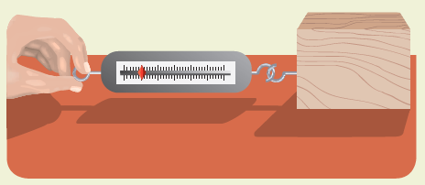

• Repeat your measurement two more times on the desktop and calculate the average force of friction. Record all data in the table.
• Repeat this procedure on several other surfaces. Surfaces that you might test are vinyl floor, carpet, doormat, concrete and bitumen.

Part 2 Different masses

• Use a spring balance to pull a block of wood across your desktop. As long as you pull steadily, the reading on the spring balance will be equal to the force of friction on the moving block.
• Record your reading in the table below.
• Add 50 g to the block and repeat the above procedure.
• Repeat the process for 100 g, 150 g, and 200 g.

Results:

Part 1

SURFACE | FORCE OF FRICTION (N)
SURFACE | TRIAL 1 | TRIAL 2 | TRIAL 3 | AVERAGE

Part 2

MASS (g) | FORCE OF FRICTION (N)
MASS (g) | TRIAL 1 | TRIAL 2 | TRIAL 3 | AVERAGE
0
50
100
150
200

Discussion:

Conclusion:

1. When the surface is rough, the friction is

2. As the mass of the block increases, the friction is

